**ReactJS-HOL 1**

**Questions & Answers –**

* **Define SPA and its benefits**

**Ans -** SPA (Single Page Application) is a type of web application that dynamically updates the content of a single web page without requiring full page reloads from the server. Instead, it loads the necessary resources once and then updates the view using JavaScript as the user interacts with the app.

**Benefits of SPA:**

* Faster performance: Only data is fetched from the server, not the entire HTML page.
* Seamless user experience: Navigation feels smooth without page refreshes.
* Reduced server load: Since most rendering happens on the client-side.
* Efficient development: Code reusability and easier maintenance with frameworks like React or Angular.
* **Define React and identify its working**

**Ans -** React is a JavaScript library developed by Facebook for building user interfaces, especially for single-page applications. It allows developers to build reusable UI components and efficiently update and render data changes.

**Working of React:**

* React uses a component-based architecture.
* It maintains a virtual DOM, which is a lightweight copy of the real DOM.
* When the state or data changes, React updates only the changed parts by comparing the new virtual DOM with the previous one (diffing algorithm).
* It then applies the minimal changes to the real DOM for better performance.
* **Identify the differences between SPA and MPA**

**Ans –**

| **Feature** | **SPA (Single Page Application)** | **MPA (Multi Page Application)** |
| --- | --- | --- |
| Page reloads | No full page reloads | Reloads the entire page |
| Speed | Faster after initial load | Slower due to full reloads |
| Data loading | Uses AJAX/fetch for data | Loads from server on every page |
| Development | Complex client-side routing | Simpler structure with multiple HTML files |
| SEO | Harder to optimize for SEO | Better SEO support by default |
| Examples | Gmail, Facebook, Twitter | Amazon, eBay |

* **Explain Pros & Cons of Single-Page Application**

**Ans –**

**Pros:**

* Fast and responsive UI
* Better user experience
* Smooth transitions between views
* Reusable components (with frameworks like React or Angular)

**Cons:**

* Initial load time can be high
* Poor SEO support without additional tools
* Browser history and back button handling is more complex
* Security concerns (like XSS) if not properly handled
* **Explain about React**

**Ans -** React is a declarative, component-based JavaScript library used for building interactive user interfaces. It is especially suited for building SPAs where frequent updates are needed.

**Key Concepts:**

* JSX: JavaScript + XML syntax to write UI code.
* Components: Reusable blocks of code (either functional or class-based).
* State and Props: For managing dynamic data in components.
* Hooks: (like useState, useEffect) to manage side effects and state in functional components.
* **Define virtual DOM**

**Ans -** The Virtual DOM is a lightweight, in-memory representation of the real DOM used by React. When the state of a component changes, a new virtual DOM is created. React then compares it with the previous version using a diffing algorithm and updates only the necessary parts in the actual DOM.

**Benefits:**

* Faster updates and rendering
* Minimizes direct DOM manipulation
* Improves performance and efficiency
* **Explain Features of React**

**Ans – Features of React:**

1. **Component-Based Architecture:** UI is built using isolated, reusable pieces.
2. **Virtual DOM:** Improves performance by reducing direct DOM manipulations.
3. **JSX Syntax:** A syntactic extension of JavaScript that looks like HTML.
4. **Unidirectional Data Flow:** Data flows in one direction, making apps predictable.
5. **Hooks:** Enable functional components to manage state and side effects.
6. **Declarative UI:** You describe what UI should look like for each state.
7. **Large Ecosystem:** Includes tools for routing, state management, testing, etc.

**Hands-On: (Code)**

*App.js –*

import './App.css';

function App() {

  return (

    <h1>welcome to the first session of React</h1>

  );

}

export default App;

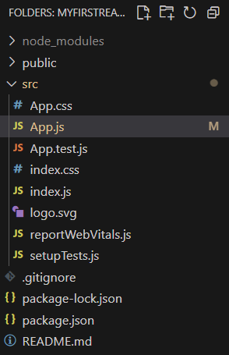

* Running on Port 3000

